Week3
- Detection concepts
Classification vs. Localization vs. Detection
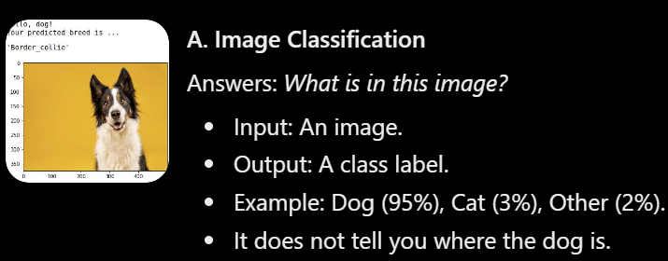
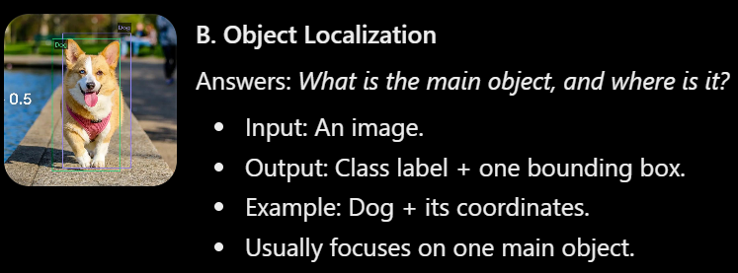
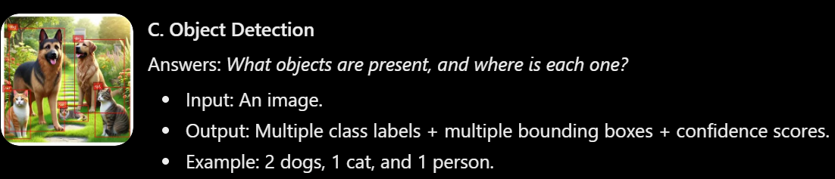
Bounding Boxes
A bounding box is a rectangle drawn around an object to indicate its location in an image.
There are two common ways to represent bounding boxes.
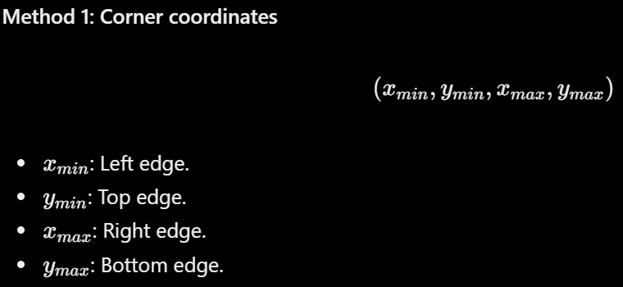
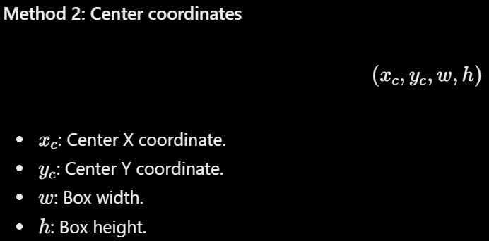

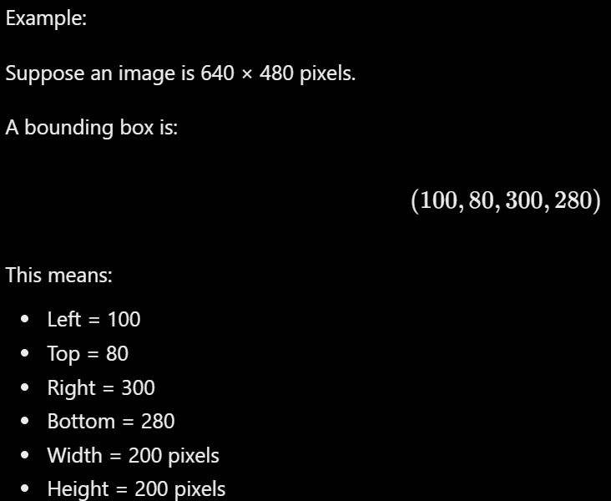
Important: Bounding boxes can be represented in absolute pixel coordinates or normalized coordinates (usually between 0 and 1).
Find one well regarded explainer or paper on IoU, anchors, and NMS, read it, and note which one you used.

IoU – Intersection over Union
IoU measures how much a predicted bounding box overlaps with the actual ground-truth bounding box.
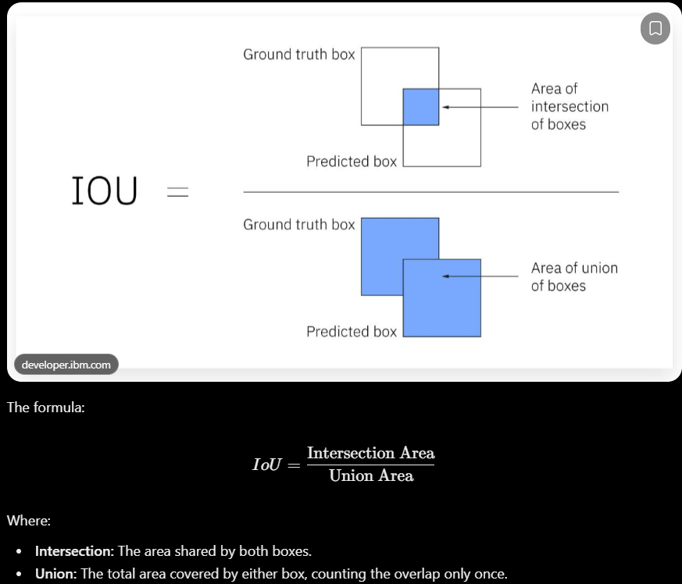
Why do we need IoU?
Because detecting an object is not enough. We also need to measure how accurately the model located it.
IoU is used to evaluate bounding boxes and in object detection metrics such as mAP.

Anchor Boxes
Anchor boxes are predefined bounding boxes with different shapes and sizes that help an object detector predict objects of different dimensions.
Using only one box shape would make detecting all these objects difficult. Instead, the model starts with multiple predefined box shapes.
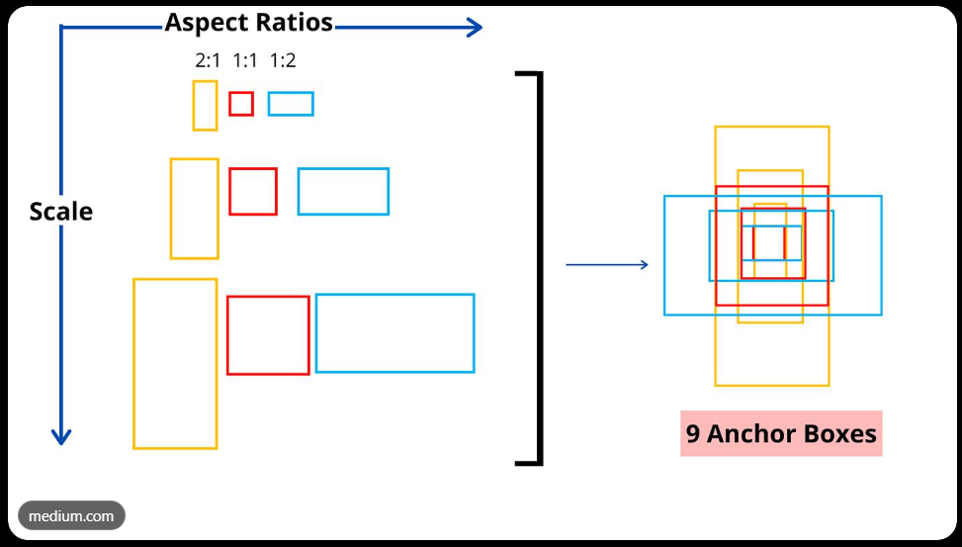
Important concepts:
Aspect ratio: Relationship between width and height.
Scale: How large the box is.
Anchor: A predefined starting box.
Regression: Predicting adjustments to the anchor coordinates.
Not all detectors use anchor boxes. For example, modern anchor-free detectors predict object locations without predefined anchor shapes.

One-Stage vs. Two-Stage Detectors
One-stage detectors – YOLO
The idea:
Input an image.
Extract image features using a neural network.
Predict bounding boxes, class probabilities, and confidence scores.
Apply post-processing such as NMS.
Return the detected objects.
It predicts objects directly without a separate region proposal stage.
Advantages:
Fast inference
Suitable for real-time applications.
Efficient for applications such as surveillance and autonomous systems.
Disadvantages:
- Can struggle with some difficult cases, such as small or crowded objects, depending on the model and version.

Two-stage detectors – Faster R-CNN
Stage 1: Region Proposal Network (RPN)
Examines image features.
Suggests regions that might contain objects.
Generates region proposals.
Stage 2: Detection
Examines the proposed regions.
Classifies each region.
Refines the bounding boxes.
Advantages:
Strong detection accuracy in many settings.
Explicitly examines proposed object regions.
Disadvantages:
Generally more computationally expensive.
Usually slower than comparable one-stage detectors.
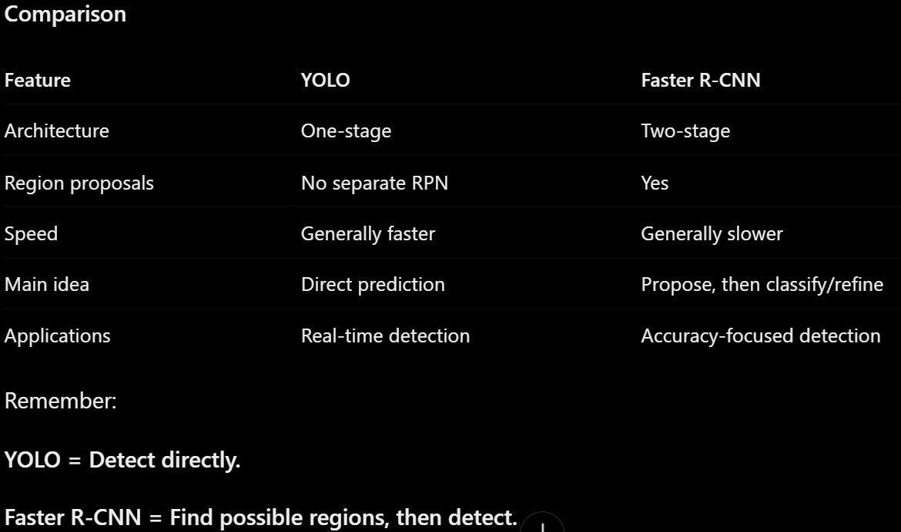

Non-Maximum Suppression (NMS)
Imagine your model detects one dog but predicts five overlapping bounding boxes around it.
Should the output contain five dogs?
No. They are multiple predictions for the same object.
NMS solves this problem.
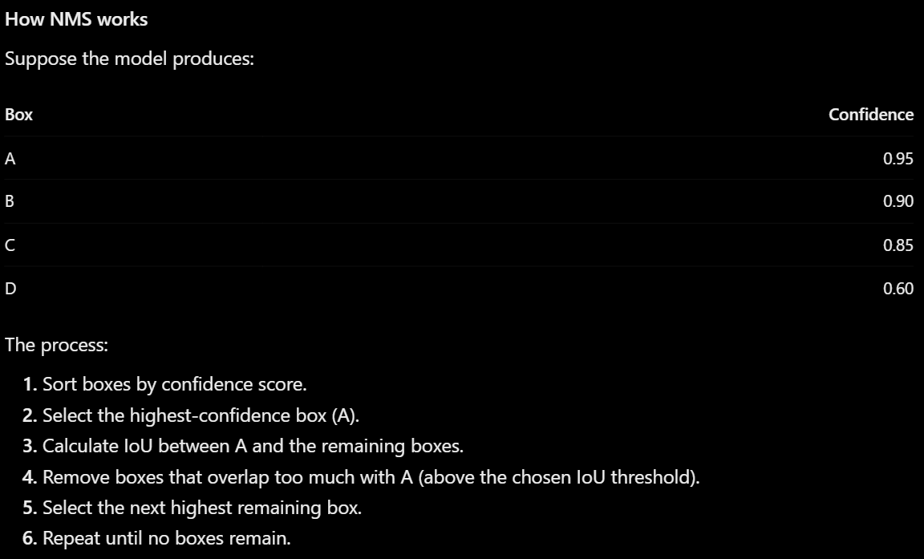
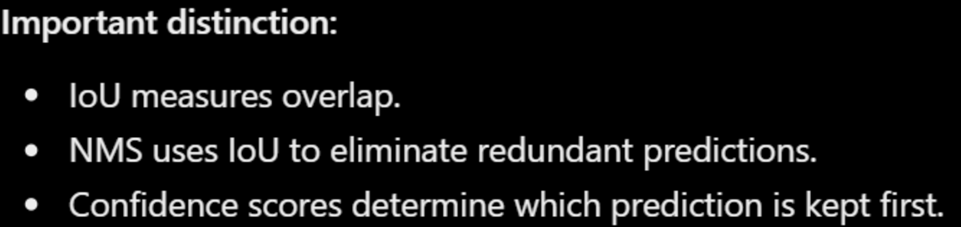

mAP – Mean Average Precision
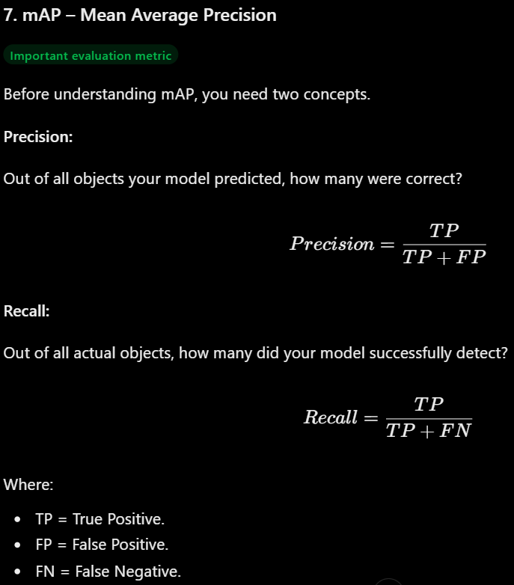
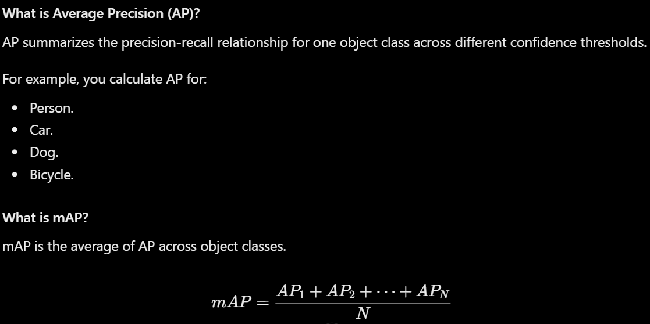
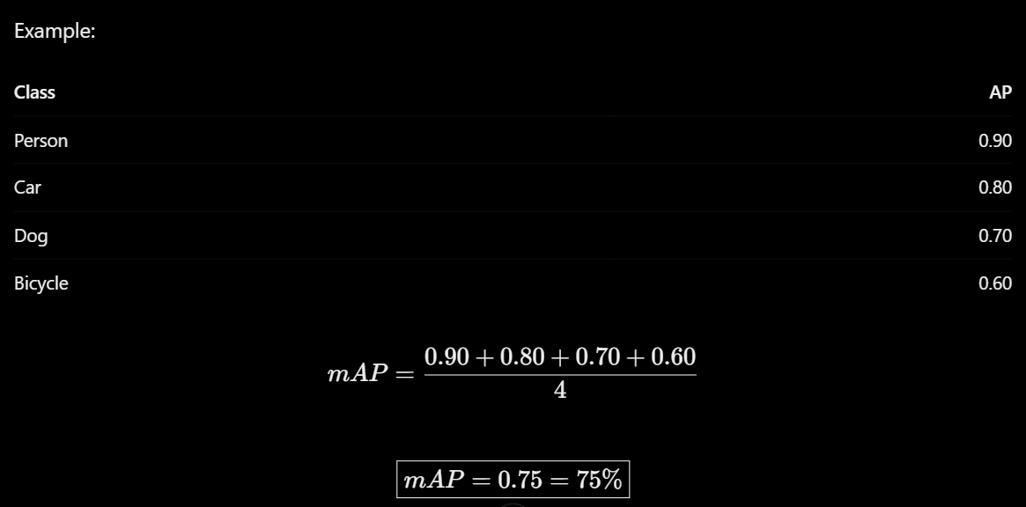
mAP@0.5 vs. mAP@0.5:0.95
These are common evaluation metrics.
mAP@0.5: A prediction is considered a true positive if its IoU is at least 0.5.
mAP@0.5:0.95: AP is calculated at IoU thresholds 0.50, 0.55, 0.60, ... 0.95, then averaged.
The second metric is stricter because it evaluates localization quality at several overlap thresholds.
mAP@0.5 measures how accurately an object detector identifies objects when the predicted bounding box has an IoU of at least 0.5 (50% overlap) with the actual bounding box. mAP@0.5:0.95 is stricter because it calculates the Average Precision (AP) at 10 different IoU thresholds, from 0.50 to 0.95, increasing by 0.05, and then averages the results. This means the model must not only detect the correct objects but also draw increasingly accurate bounding boxes around them. Therefore, mAP@0.5:0.95 provides a more comprehensive evaluation of detection and localization quality.

Why not accuracy?
Classification accuracy does not adequately measure object detection performance.
Object detection must evaluate:
Whether the object was identified correctly.
Whether the object was missed.
Whether incorrect objects were detected.
Whether the bounding box was placed accurately.
mAP accounts for detection precision, recall, and localization quality through IoU-based matching.

Write short answers:
why not use a sliding window?
Sliding windows are computationally expensive because they require evaluating many windows at different positions, sizes, and aspect ratios. Modern object detectors share feature extraction and predict multiple objects more efficiently.
what IoU measures?
IoU (Intersection over Union) measures the overlap between a predicted bounding box and a ground-truth bounding box. It is calculated by dividing their intersection area by their union area. Its value ranges from 0 to 1.
what NMS fixes?
Non-Maximum Suppression removes redundant overlapping bounding boxes that predict the same object. It keeps the box with the highest confidence score and suppresses other boxes whose IoU with it exceeds a predefined threshold.
why mAP is more informative than accuracy?
Accuracy is not sufficient for object detection because a detector must identify multiple objects and accurately locate each one. mAP evaluates precision and recall across confidence thresholds, uses IoU to determine whether localization is correct, and averages performance across object classes.


